ME 371 Final Project Report

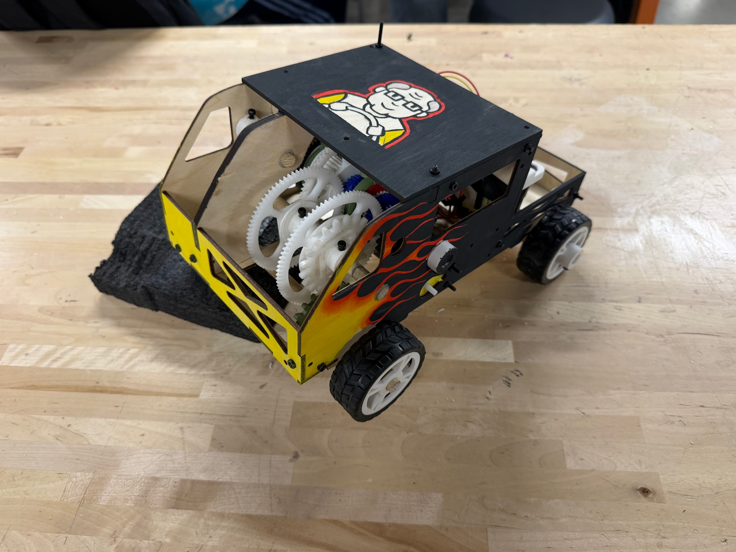
Team 7
AL2
Christopher Egly, Neil Maushard, Phoebe Mihevc, Peyton Schwake

Table of Contents
1. Overview 3
2. Bill of Materials 5
3. Machine Component Analysis 16
4. FEA Stress Analysis 21
5. Reflection 25
6. Appendix 28

1. Overview
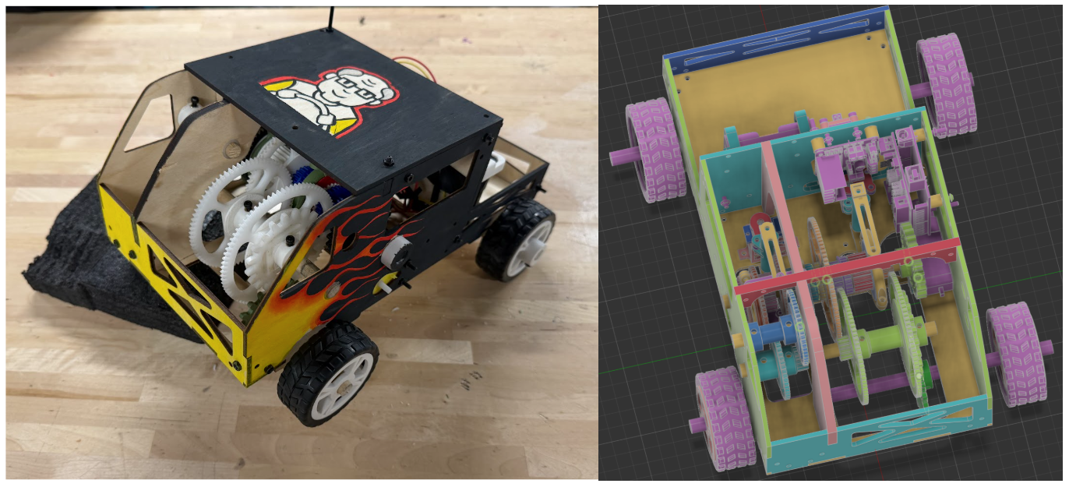
Figure 1: Fully assembled car, and CAD rendering

The goal of this project as a whole is to evaluate customer profiles, convert the feelings and needs of each customer into physical requirements, and to finally choose and develop a solution for one of the customer profiles. The customer chosen was George Alvarez. He was chosen for various reasons, not limited to: total budget, interesting combination of technical abilities (agility, speed, strength), and most importantly the allocation of one additional servo motor for changing gears. From George’s profile, the following requirements were extracted: The vehicle must exceed 1m/s, 3kg towing capacity, 8 1 meter agility traversals, be of high quality, cost less than $50, survive a 3kg drop, and have greater than 40% gearbox efficiency. In order to meet these requirements, a design philosophy was adopted. The main pillars of such philosophy are as follows: the vehicle should be compact, structurally rigid, and most importantly buttery smooth. Each of these components of the final design will be reviewed in the following sections. The final design can be viewed in figure 1.
Compactedness: By designing a car that is made of compact components it will (by extension) also be compact. Additionally, a direct result of a compact car is that there is less mass to support and also shaft support locations are closer together which reduces the bending load on shafts. By designing for compactedness, the functional benefits naturally follow. Because the car is compact and the shafts well supported, they can be made out of wooden dowels which saves money and rotational inertia (helps with acceleration in speed-related tasks). This feature/design philosophy directly contributed to the design of the chassis, servo mounting locations, and hybrid dog/sliding mesh transmission. This shifting mechanism directly contributes to performance in the agility, speed, efficiency and quality sections of the rubric. It will be discussed in detail later in this document.
Structural Rigidity: A natural side effect of a structurally rigid design is that axial alignment of shaft supports is easier to maintain. This directly contributes to the efficiency, strength, speed, and agility tests. One specific feature derived from this philosophy is the use of laser-cut puzzle piece walls connected with headset inserts and corner brackets. By using laser-cut wood, the strength of the vehicle is improved, and the weight is reduced. This once again supports the goal of improving performance in nearly every task. The most important effect of structural rigidity is the performance in the impact test. Plywood is exceptionally strong in compressive strength and when connected together in a puzzle-piece box configuration, the risk of bending failure is reduced significantly.
Buttery Smoothness: This design philosophy was the team’s north star. If any part of the design could not be described as “buttery smooth” it was reworked. A few of the features associated with this philosophy are as follows: delrin inserts on shaft interfaces, delrin spacers between any two rubbing components, delrin shaft alignment inserts for idle gears that needed to spin in place, holes to reduce gear inertia, delrin-keyed gears for power transmission, and last but not least “christmas tree gears” to allow for shaft tolerance (simply a 3D printed mounting piece that reduced the skew of gears in the axial direction). All of these features combined allowed the transmission to very effectively transmit power for all tasks. Speed, agility, and strength are of particular importance in relation to this philosophy.
Shifting Mechanism: The shifting mechanism was controlled via IR remote and arduino script. The arduino controlled the position of two servos. When shifting between gears, both servos would move to the idle position and after a short delay the correct servo for the corresponding gear would move to the correct position. The physical shifting mechanism was a combination of a dog clutch and a sliding mesh transmission. This allowed the team to use two servos to control 5 different levels of transmission, 1-4 and reverse (R). Servo 1 controlled gears R, 1, and 2, while servo 2 controlled gears 4, and 5. In order to transfer power, a dog clutch was actuated via servo, through a linkage, a sliding ring, and onto the dog teeth. The sliding ring allows for infinite rotation while still being able to apply horizontal forces and a sliding pin joint allows for the arc of the servo arm to be translated into linear movement. Attaching the linkage on the top and bottom of the ring connection removed the moment that could have bound the shifter. It also allowed the force to be applied entirely axially, improving strength and efficiency. The gear ratios are summarized in table 1 below:
Table 1: Gear ratio summary
 | Reverse | 4 (high speed) | 3 | 2 | 1
Ratio | 1:1 | 2:1 | 1:3 | 1:12 | 1:18

2. Bill of Materials
All custom parts include a thumbnail image in the “Custom Part Images” column. The components without an image were purchased. All 3D-printed parts are made of PLA and were printed using a personal printer.
Table 2: Bill of Materials
Component | Unit Price | Quantity Purchased | Source | Mass (g) | Total Cost | Custom Part Images
Heat set insert | $0.200 | 10.000 | Innovation Studio | N/A | $2.00 | N/A
dowel | 0.500 | 2.000 | Innovation Studio | N/A | $1.00 | N/A
1-2-in-5-14, PLA | N/A | 1 | Personal | .774 | $0.02 | 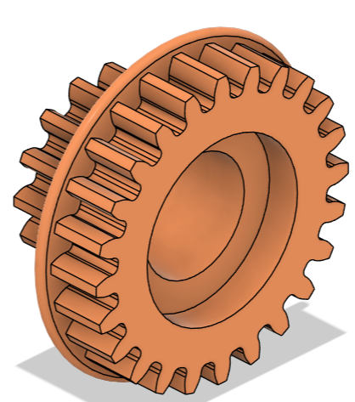
4-5-Collar, PLA | N/A | 1 | Personal | 1.553 | $0.05 | 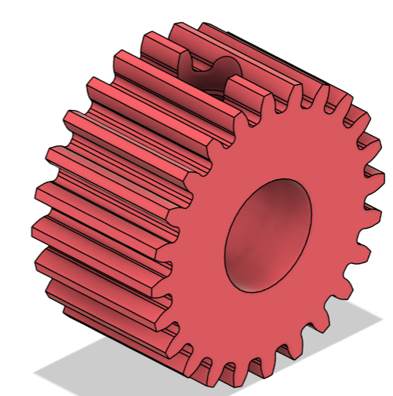
1-2-in-4-20, PLA | N/A | 1 | Personal | 1.109 | $0.03 | 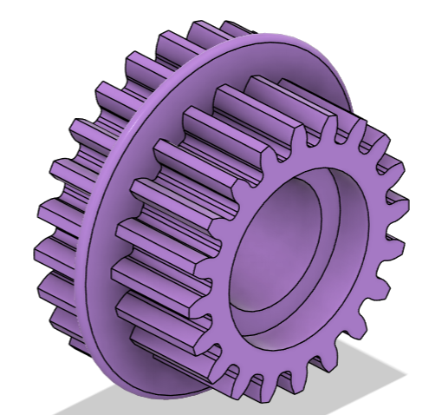
2-3-collar, PLA | N/A | 1 | Personal | 1.935 | $0.06 | 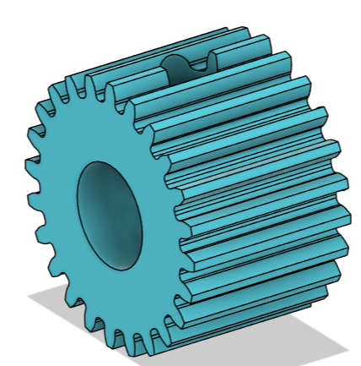
1-1a-in-1-45 key, PLA | N/A | 1 | Personal | .8596 | $0.03 | 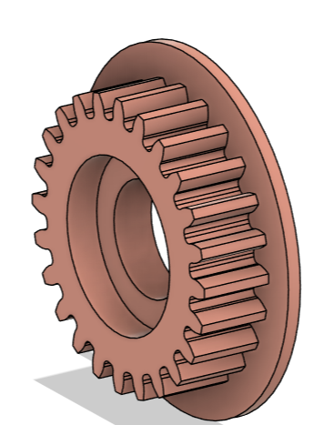
Sliding mesh key, PLA | N/A | 1 | Personal | 3.376 | $0.10 | 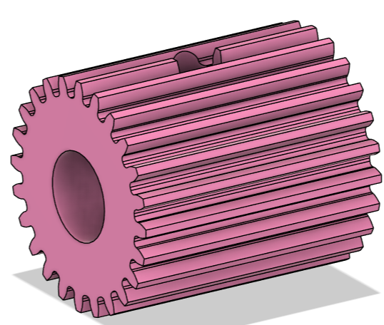
1-2-in-3-49 | N/A | 1 | Innovation Studio | N/A | N/A | 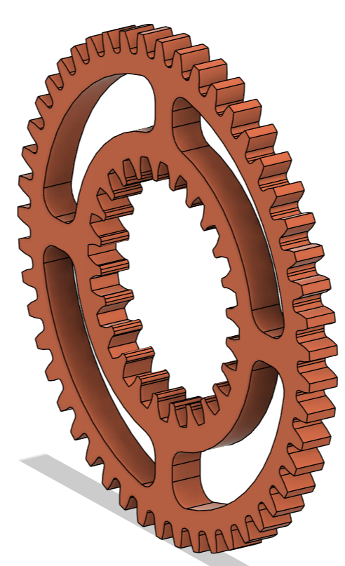
1-2-in-2-84 | N/A | 1 | Innovation Studio | N/A | N/A | 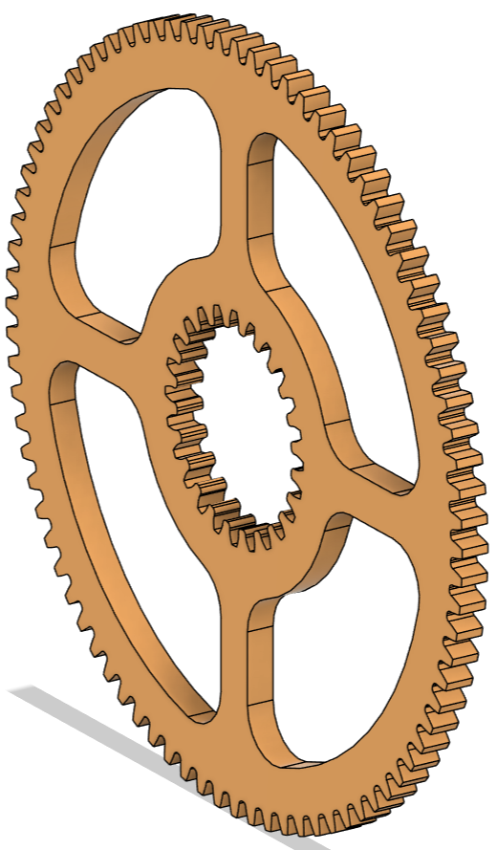
1-2-in-2-84, PLA | N/A | 1 | Personal | 1.028 | $0.03 | 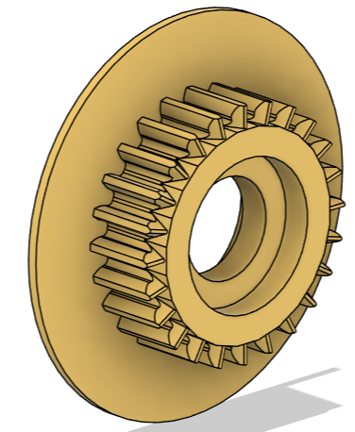
Rev-idler delrin | N/A | 1 | Innovation Studio | N/A | N/A | 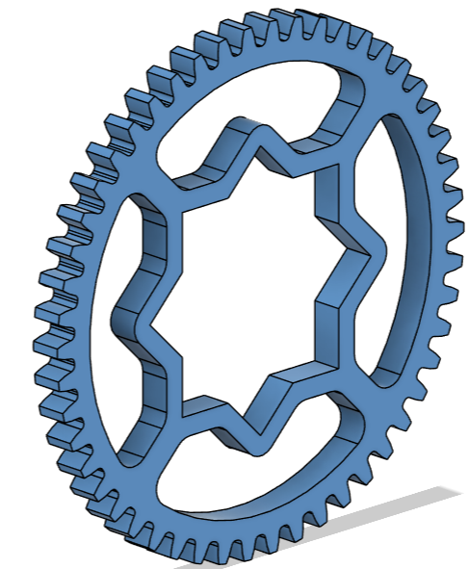
Rev-idler key, PLA | N/A | 1 | Personal | 1.958 | $0.06 | 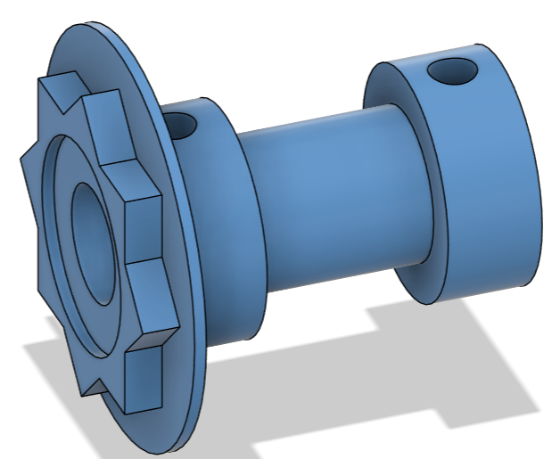
Rev 3 out key, PLA | N/A | 1 | Personal | 2.761 | $0.08 | 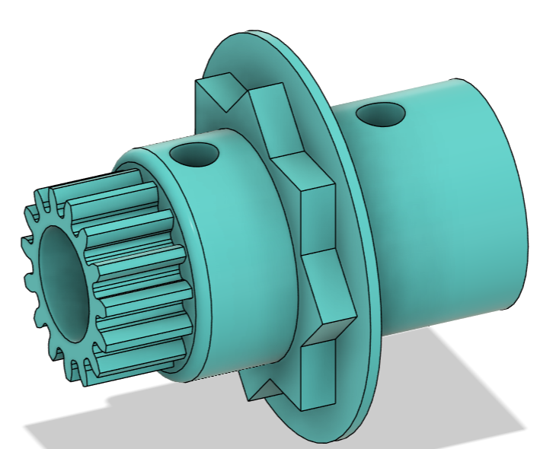
Rev 3 out delrin | N/A | 1 | Innovation Studio | N/A | N/A | 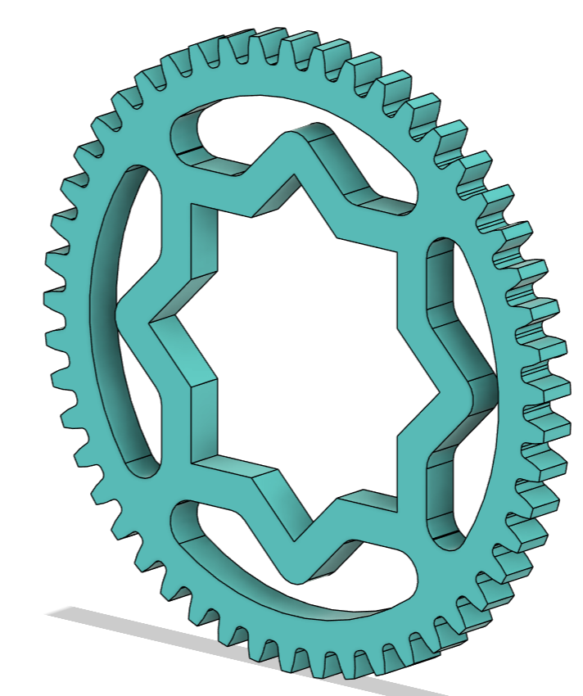
Big christmas tree key, PLA | N/A | 1 | Personal | 4.671 | $0.14 | 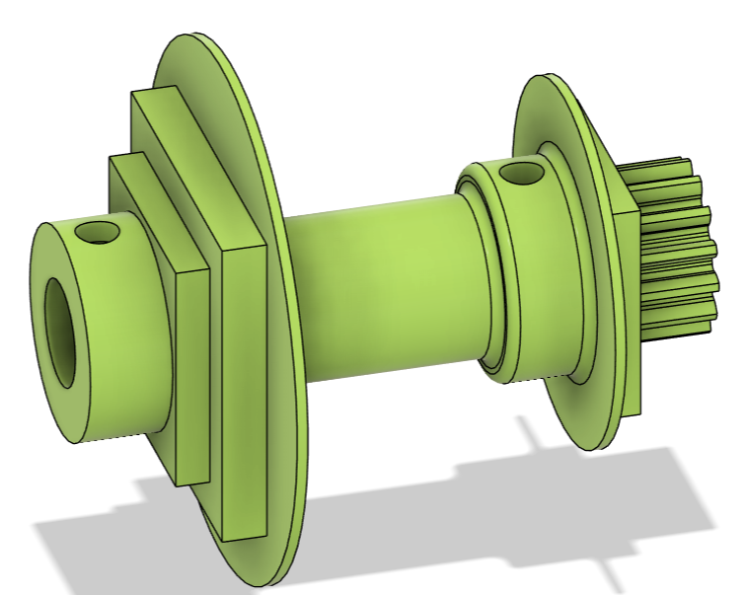
Big christmas tree big teeth | N/A | 1 | Innovation Studio | N/A | N/A | 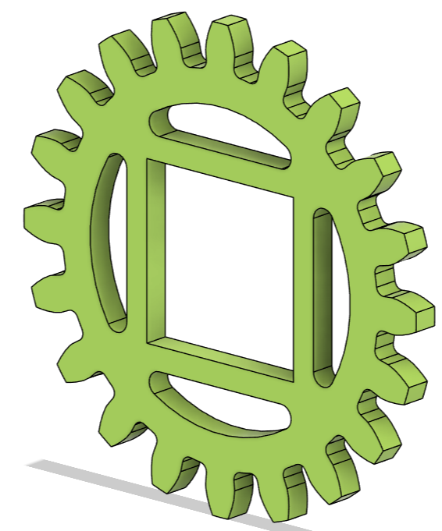
Big christmas tree med gear | N/A | 1 | Innovation Studio | N/A | N/A | 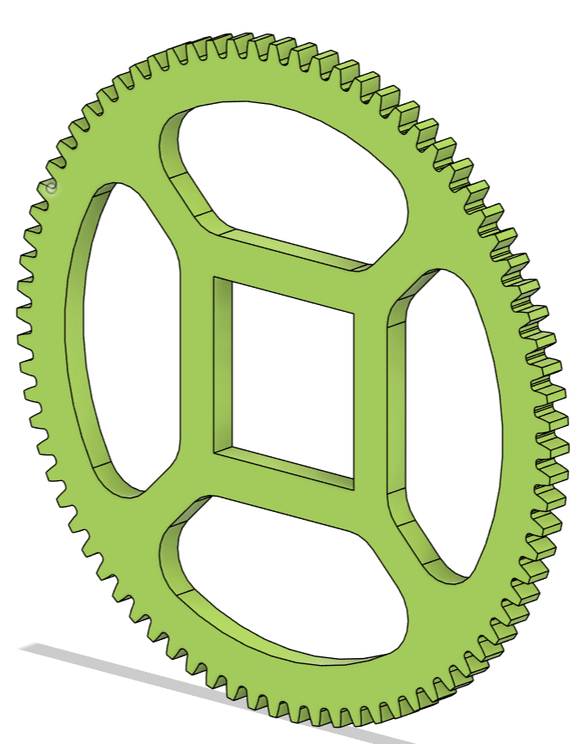
Big christmas tree biggest gear | N/A | 1 | Innovation Studio | N/A | N/A | 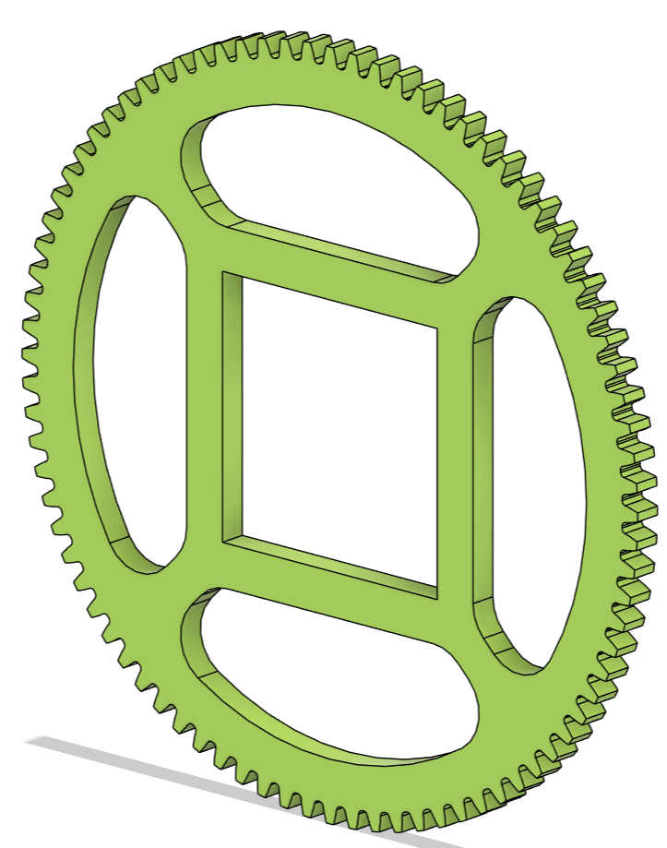
1-1a-in-1-45 | N/A | 1 | Innovation Studio | N/A | N/A | 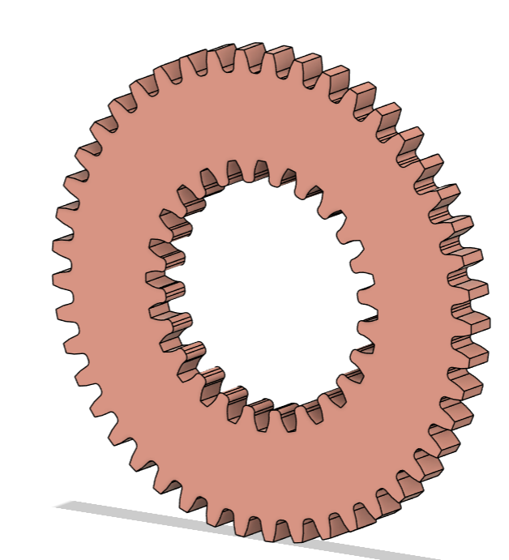
Delrin s4 | N/A | 5 | Innovation Studio | N/A | N/A | 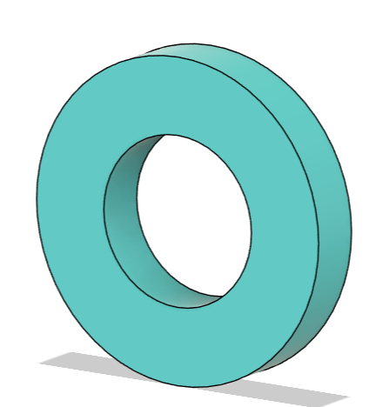
Motor gear | N/A | 1 | Innovation Studio | N/A | N/A | 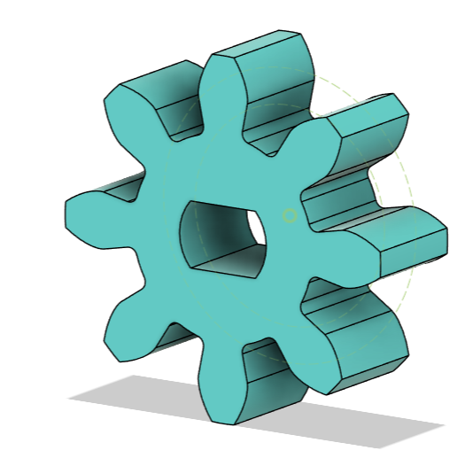
0-1-out-0-36 big teeth, PLA | N/A | 1 | Personal | 3.873 | $0.12 | 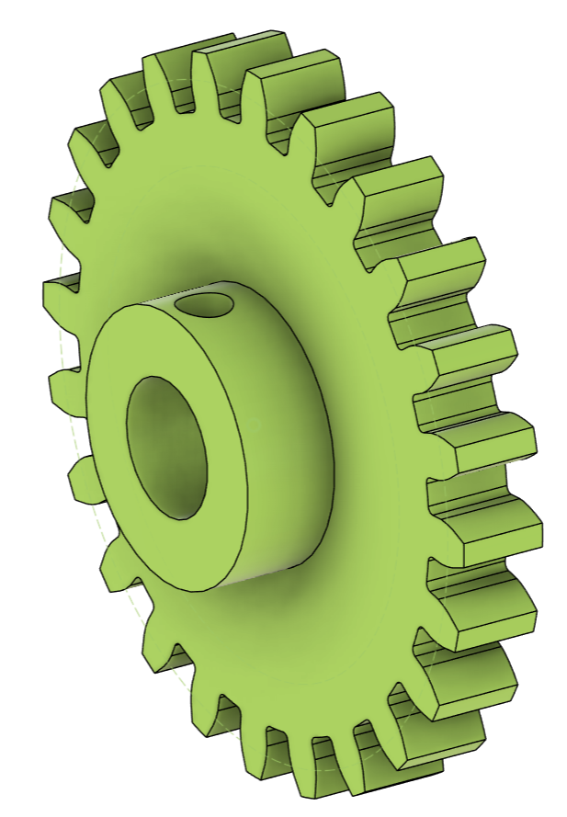
Chassis
Tire | $0.40 | 4.000 | Found | N/A | $2.40 | N/A
3/8" Wooden Dowel, 12in | $0.50 | 2.000 | Innovation Studio | N/A | $1.00 | N/A
M3 Screw 16mm | $0.17 | 34.000 | Innovation Studio | N/A | $5.68 | N/A
M3 Screw 20mm | $0.14 | 2.000 | Innovation Studio | N/A | $0.29 | N/A
M3 Nut | $0.03 | 36.000 | Innovation Studio | N/A | $1.19 | N/A
Baseplate | N/A | 1 | Innovation Studio | N/A | N/A | 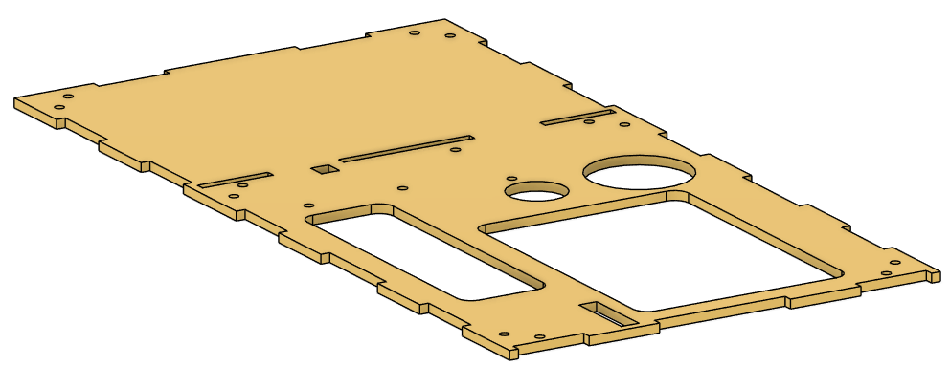
Transmission wall middle | N/A | 1 | Innovation Studio | N/A | N/A | 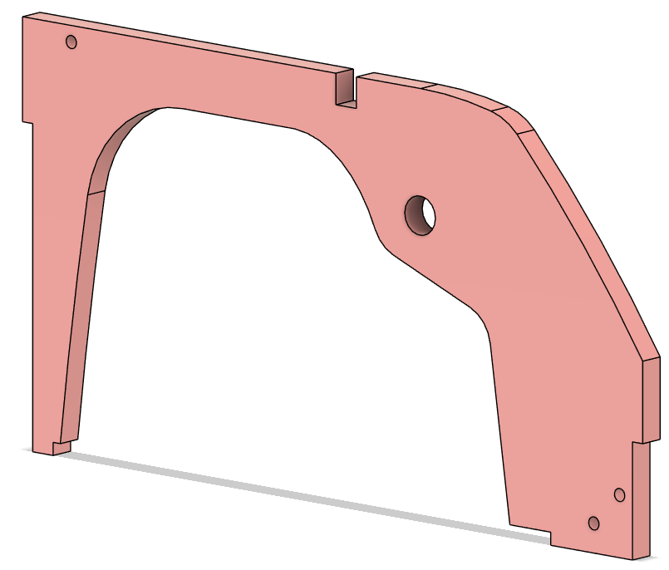
Gas front wall | N/A | 1 | Innovation Studio | N/A | N/A | 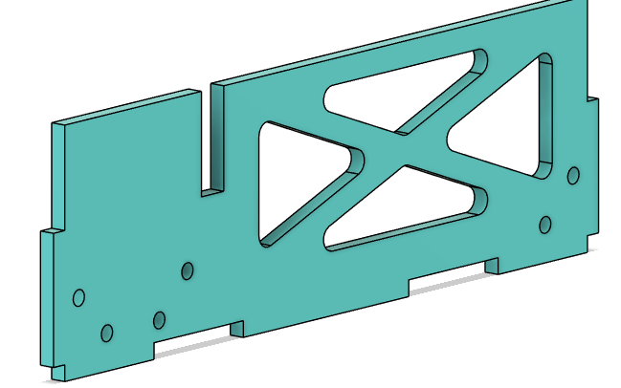
Gas side wall | N/A | 2 | Innovation Studio | N/A | N/A | 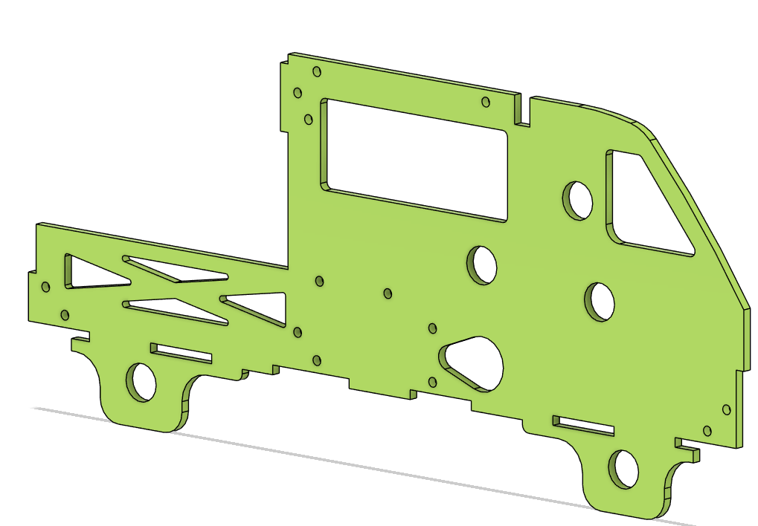
Gas rear wall | N/A | 1 | Innovation Studio | N/A | N/A | 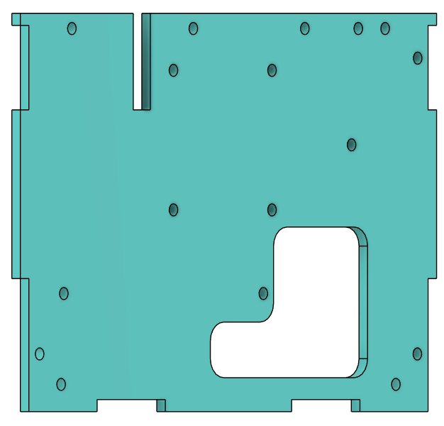
Battery bracket | N/A | 1 | Personal | 2.192 | 0.07 | 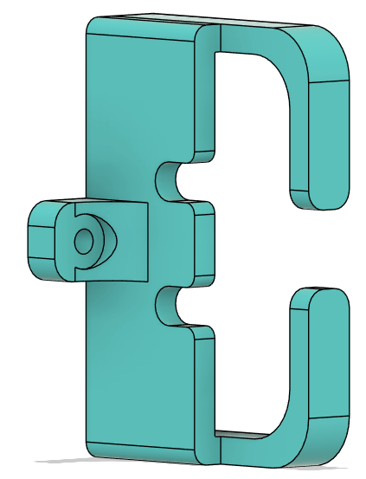
Ir holder, PLA | N/A | 1 | Personal | 0.079 | 0.00 | 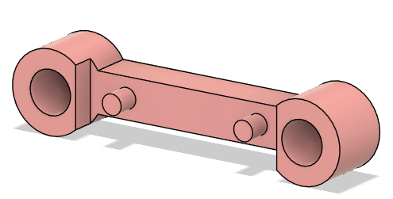
Standoff for motor controller, PLA | N/A | 2 | Personal | 0.097 | 0.00 | 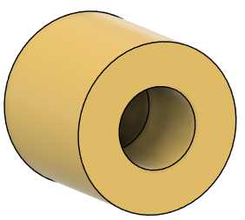
Truck hatch | N/A | 1 | Innovation Studio | N/A | N/A | 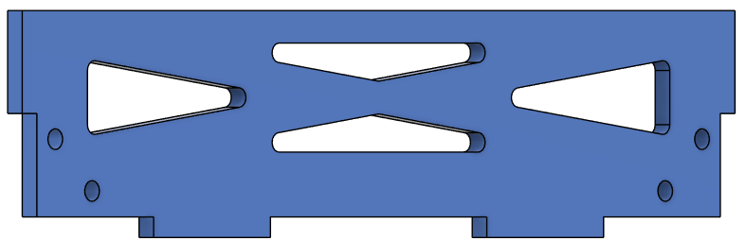
Arch | N/A | 1 | Innovation Studio | N/A | N/A | 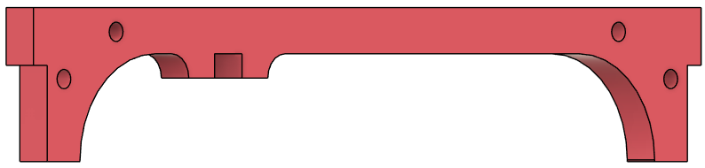
Wheel hub, PLA | N/A | 4 | Personal | 3.585 | .43 | 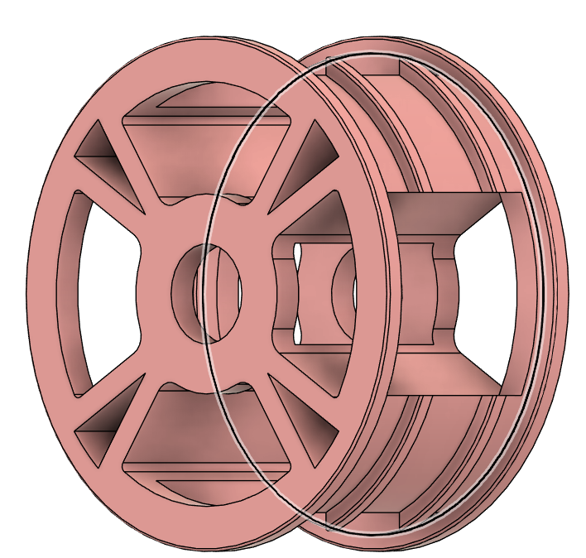
Delrin s2 | N/A | 7 | Innovation Studio | N/A | N/A | 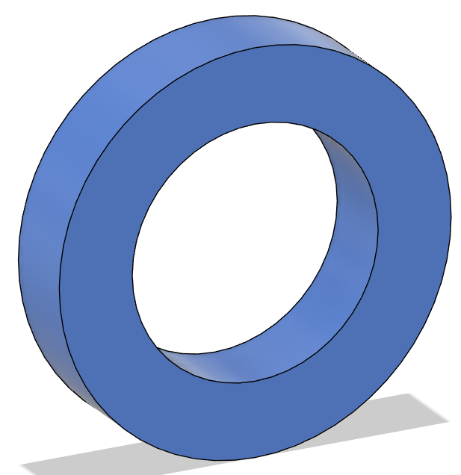
Delrin s1 | N/A | 10 | Innovation Studio | N/A | N/A | 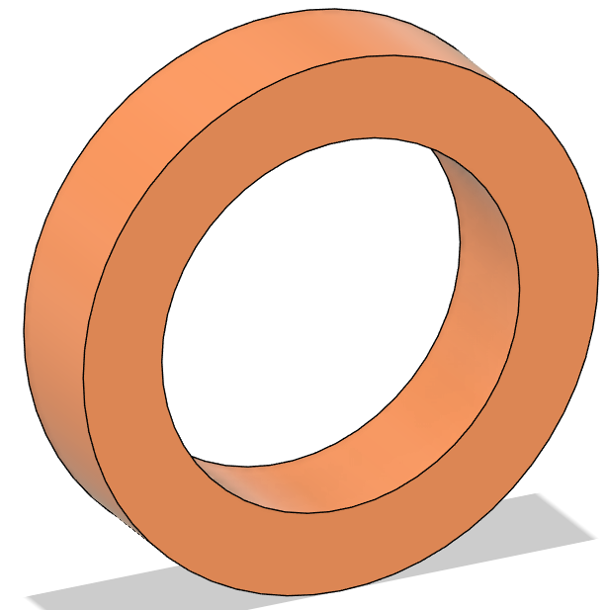
Gear Shifting
Heat set insert | $0.200 | 8.000 | Innovation Studio | N/A | $1.60 | N/A
HDRHS M3 x 10 | $0.167 | 15.000 | Innovation Studio | N/A | 2.51 | N/A
Hex Nut M3 | $0.025 | 8.000 | Innovation Studio | N/A | $0.20 | N/A
PLA | $0.030 | 2.677g | Innovation Studio | N/A | $.08 | N/A
Collar screw clamp, PLA | N/A | 2 | Personal | 0.231 | .02 | 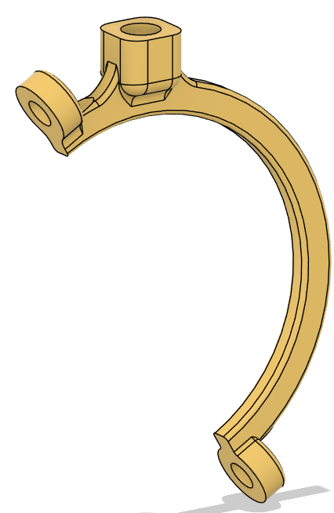
Collar with recess, PLA | N/A | 2 | Personal | 1.451 | 0.08 | 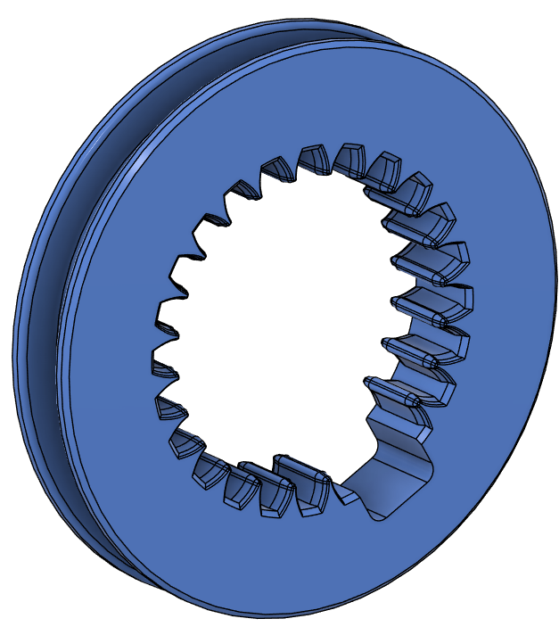
Pusha rod, PLA | N/A | 2 | Personal | 0.605 | .04 | 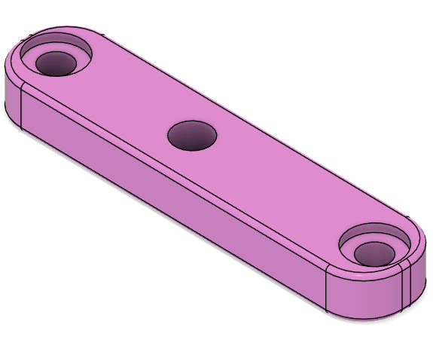
1-2-in-3-49-with-collar, PLA | N/A | 1 | Personal | 2.712 | 0.08 | 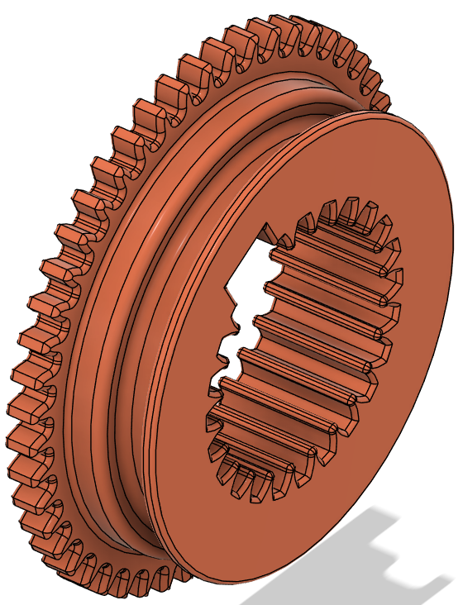
Slider arm, PLA | N/A | 2 | Personal | 0.277 | .02 | 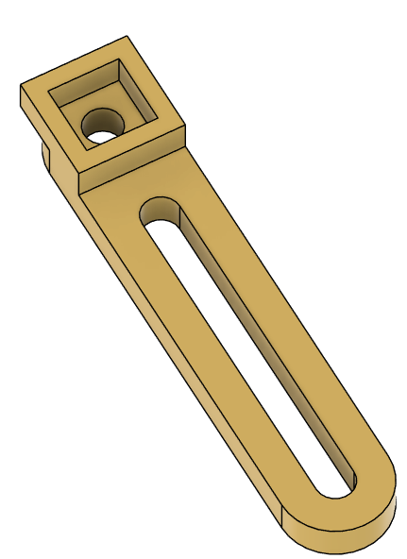
Servo connector arm gear 3-5, PLA | N/A | 1 | Personal | 0.937 | .03 | 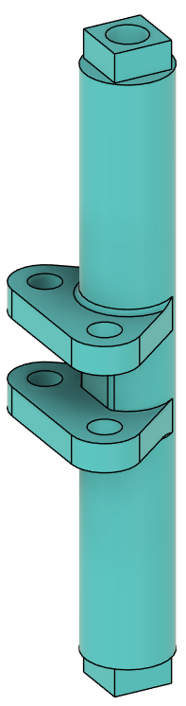
Servo lid, PLA | N/A | 2 | Personal | 0.136 | .01 | 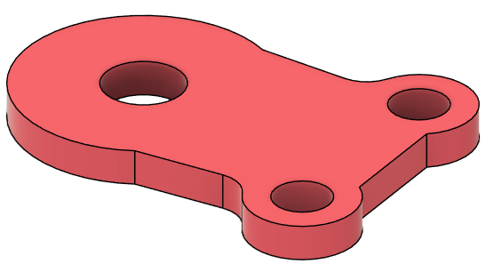
Servo bottom, PLA | N/A | 2 | Personal | 0.228 | .01 | 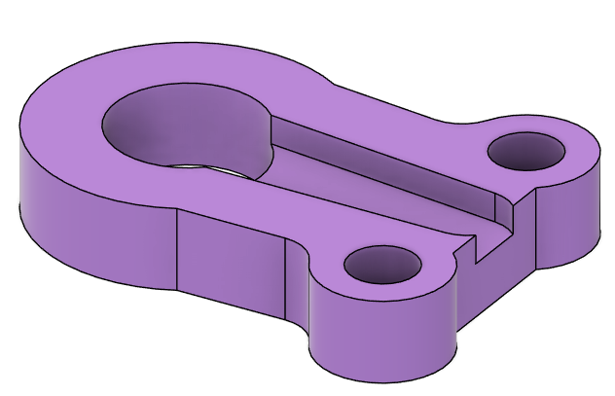
Servo mount, PLA | N/A | 2 | Personal | 0.766 | .04 | 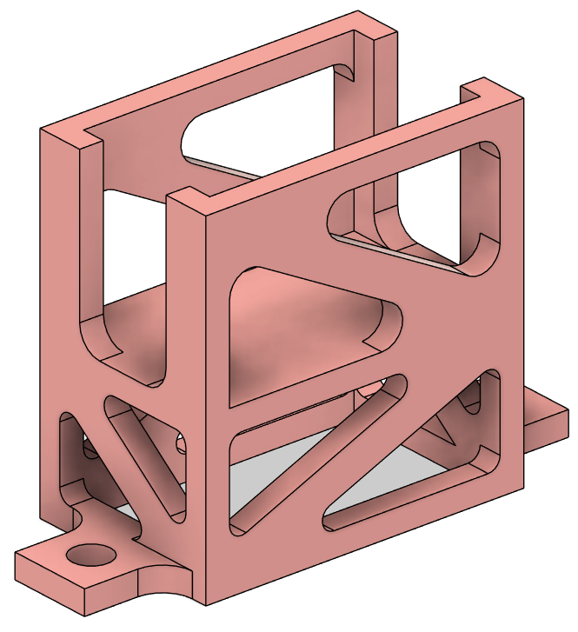
Collar screw clamp gear 1-2, PLA | N/A | 2 | Personal | 0.765 | .04 | 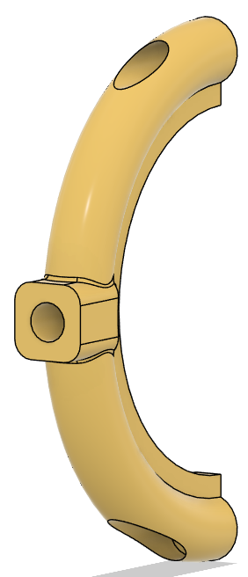
Slider arm gears 4-5, PLA | N/A | 2 | Personal | 0.322 | .02 | 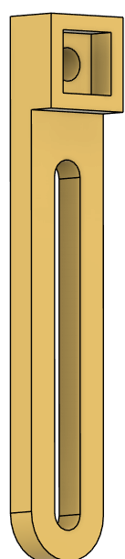
Servo connector arm, PLA | N/A | 1 | Personal | 0.814 | .05 | 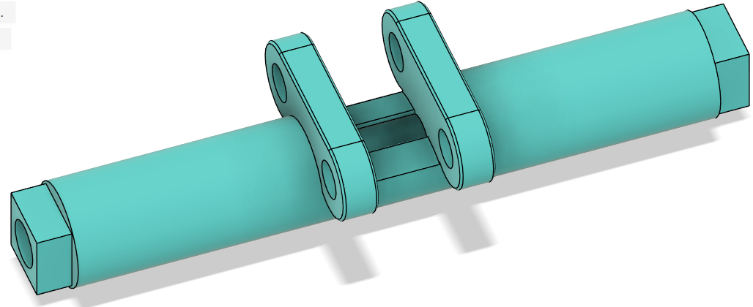
Laser Cut Material
1/4" Plywood 12x24 Sheet | $7.000 | 0.167 | Innovation Studio | N/A | $1.17 | N/A
1/8" Plywood 12x24 Sheet | $5.000 | 1.000 | Innovation Studio | N/A | $5.00 | N/A
1/4" Delrin 12x24 Sheet | $20.000 | 0.002 | Innovation Studio | N/A | $0.05 | N/A
1/8" Delrin 12x24 Sheet | $10.000 | 0.250 | Innovation Studio | N/A | $2.50 | N/A
Total cost: |  |  |  |  |  | $28.33

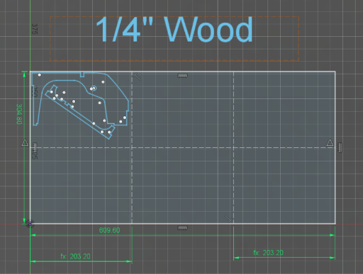
Figure 2. ¼” Plywood DXF
The ¼” plywood wood is used for the middle wall and arch. One sheet of plywood is able to fit enough material for 6 cars, leading to a unit price of ⅙ of a normal sheet price.
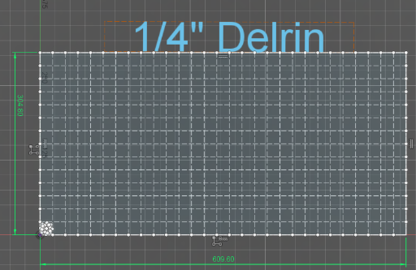
Figure 3. ¼” delrin DXF
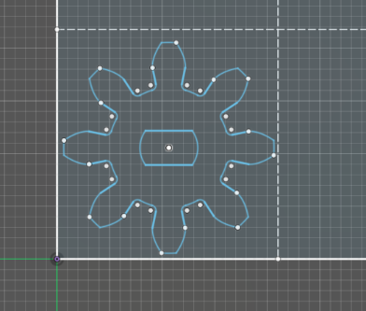
Figure 4. DXF of motor gear
The ¼” delrin is used for the motor gear. One sheet of ¼” delrin can produce components for 400 cars, leading to a unit cost of $0.05.
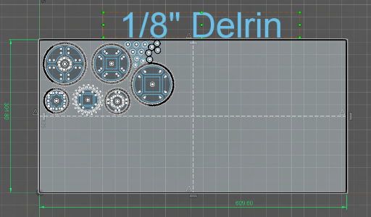
Figure 5. ⅛” delrin DXF
The ⅛” delrin is used for various gears and spacers. One sheet of ⅛” delrin can produce components for 4 cars, leading to a unit cost of $2.50.

3. Machine Component Analysis
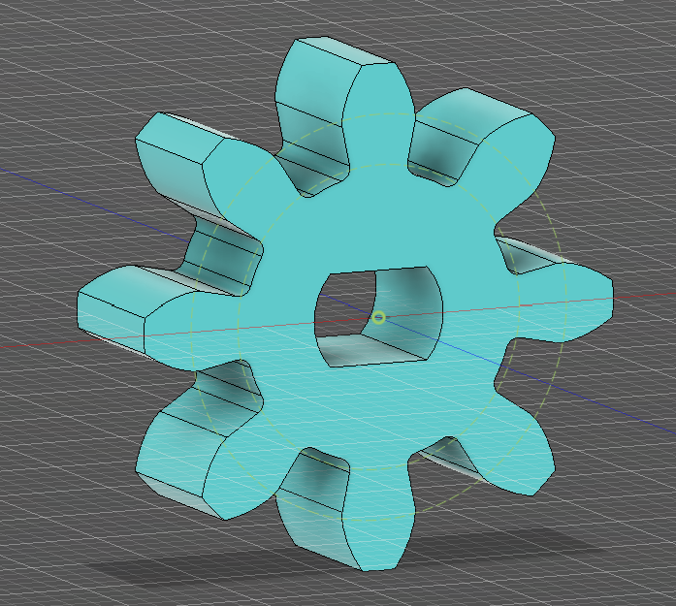
Figure 6. Motor gear CAD model

Table 3: Geometry and material properties
Pitch Diameter $d$ | $16 mm$
# of Teeth $N$ | $8$
Diametral Pitch $P$ | 12.7
Gear Width $b$ | $6.35 mm$
Ultimate Tensile Strength $σ_{u}=131 MPa$ | $131 MPa$

The spur gear will undergo cyclic loading, oscillating between having no load applied to a load of $F_{t}$ applied to the tooth.
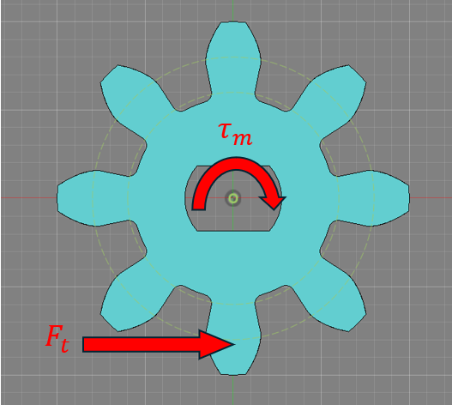
Figure 7. Motor gear free body diagram

To determine the input torque from the motor $τ_{m}$, it is assumed that the motor is running at maximum power output, meaning that $τ_{m}$ is equal to half of the stall torque $τ_{s}$. The stall torque for the motor listed on the manufacturer’s website is $τ_{s}=0.8 kg∙cm$ for operation at 6V. The motor was operated at 7.2V, so $τ_{s}$ would likely be higher in this case, but the extrapolated value would be difficult to justify, so it will be assumed that the motor is operating at
 | $τ_{m}=\frac{τ_{s}}{2}=0.4 kg∙cm≈0.039 N∙m$. | (1)
Each tooth on the gear will undergo cyclic loading ranging from an unloaded state to a maximum load $F_{t}$ when it is fully engaged with its mating gear. To determine the maximum magnitude of $F_{t}$, the assumption will be made that the motor (and therefore the gear) operate at constant rotational speed. This assumption can be made because all the speed changing comes from changing gears, not changing the speed of the motor. In reality, the speed is not exactly constant, and will fluctuate especially during gear changes, but this assumption is necessary for calculation of $F_{t}$ and is safe enough to not deviate extensively from reality. Under this assumption, $F_{t}$ can be found by equating the input torque of the motor to the torque from the mating gear, since a constant angular velocity means all external torques must cancel out. Using this, $F_{t}$ can be found as
 | $F_{t}=\frac{τ_{m}}{d/2}=\frac{0.039 N⋅m}{8 mm}=4.875 N$  $F_{t}=\frac{τ_{m}}{d/2}=4.875 N$ | (2)

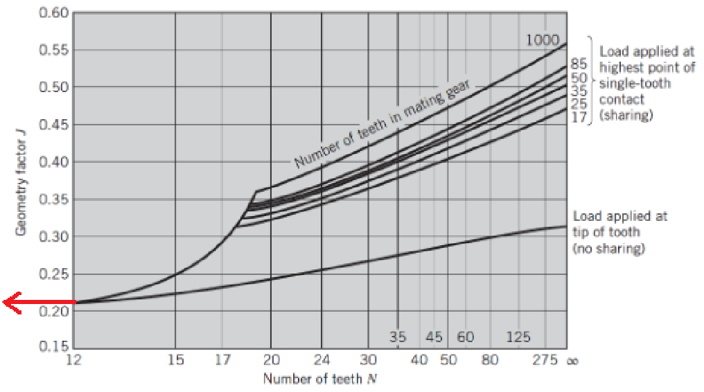
Figure 8: Chart for determining the geometry factor J with red arrow displaying assumption

Figure 8 shows that the chart used for determining the geometry factor J only displays the factor for gears with more than 12 teeth. Therefore, an extrapolating assumption needs to be made that the chart is horizontal leading up to N = 12. Under this assumption, the geometry factor J for an a spur gear with 8 teeth is the same as for a spur gear with 12 teeth, so for these calculations $J=0.215$.

To determine $K_{v}$, the equation relating to the lowest precision manufacturing will be used, since the laser cutters used to cut this Delrin are not super high quality. They leave tapered edges and while the finish is smooth, the precision is nowhere near that of even hobs shaping cutters. Under this assumption, the equation for $K_{v}$ is
 | $K_{v}=\frac{600 + V}{600}$ | (3)
where $V$ is the pitch line velocity, which the linear velocity of a point on the pitch line. This is a function of the motor angular velocity $ω_{m}$, which under the maximum power output assumption earlier is half the unloaded angular velocity $ω_{nl}$. The no load speed $ω_{nl}$ is given on the manufacturer’s website as 200 RPM, but during testing it was observed that $ω_{nl}$ was 285 RPM. The observed value will be used, since cheap motors like this usually have unreliable spec sheets. Using this value,
 | $ω_{m}=\frac{ω_{nl}}{2}=142.5 RPM$ | (4)
With this, the pitch line velocity $V$ can be found.
 | $V=πdω_{m}=\frac{π⋅16 mm ⋅142.5 RPM}{25.4 ⋅ 12}=$ 23.5 ft/min | (5)
Plugging this value into equation X yields
 | $K_{v}=\frac{600 + 23.5}{600}=1.039$ | (6)
This value seems reasonable, as the motor’s rotational speed is quite low compared to that of more heavy-duty machinery.

To determine $K_{o}$ and $K_{m}$, the following chart will be utilized:
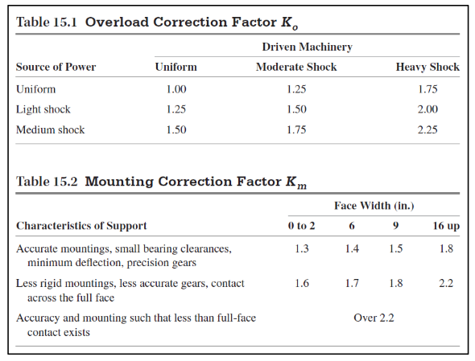
Figure 9: Tables for determining $K_{o}$ and $K_{m}$ from section 15.8, page 587 of the textbook

The source of power (the DC motor) can be assumed to run uniformly, with no significant shock. This is because our motor runs at a near constant speed during all different gears. However, the driven machinery (our geartrain) experiences some moderate shock during gear shifts when different gears are engaging and disengaging. Figure 9 shows that uniform source of power with moderate shocks in the driven machinery gives $K_{o}=1.25$. When determining $K_{m}$, it is assumed that our gears are not less accurate and that our mounting is less rigid. This is because our mounting is a simple press fit, and our gear was made with a low to moderate precision laser cutter, much less precise than some other methods of manufacturing metal gears. Our face width is well under 2 in, so figure 9 tells us that $K_{m}=1.6$.

Now that all required values are known, normal stress due to tooth bending can be calculated as
 | $σ=\frac{F_{t}P}{bJ}K_{v}K_{o}K_{m}=\frac{4.875 N ⋅ 12.7}{.00635 m ⋅ 0.215}⋅1.039⋅1.25⋅1.6=94.2 kPa$ | (7)
This value is far below the ultimate tensile strength listed on the manufacturer’s website of $σ_{u}=131 MPa$. This makes sense, as the gear is quite thick for its size, and Delrin is a relatively strong plastic, so tooth failure is understandably not a worry here. Fatigue analysis will not be conducted for this part since it is not metal.

4. FEA Stress Analysis
Table 4: Simulation Components
Component | Geometry | Material
3kg weight | 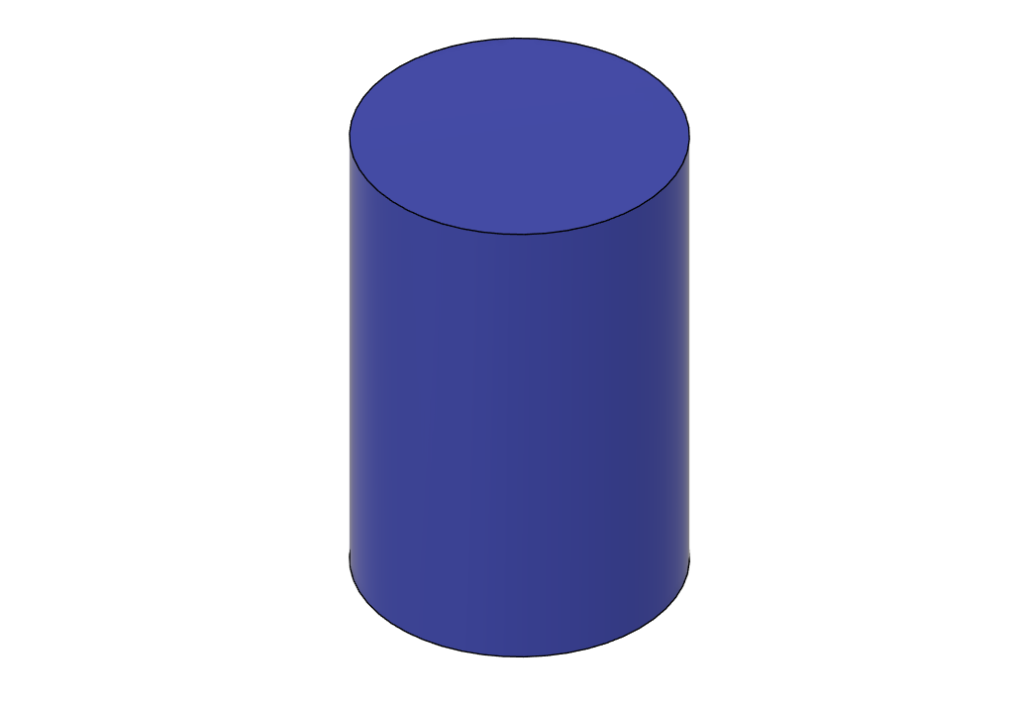 | Steel
Side Walls |  | Birch Plywood
Rear Wall |  | Birch Plywood
Front Wall |  | Birch Plywood
Back Hatch |  | Birch Plywood
Center Spine |  | Birch Plywood
Arch |  | Birch Plywood
Baseplate |  | Birch Plywood
Roof | 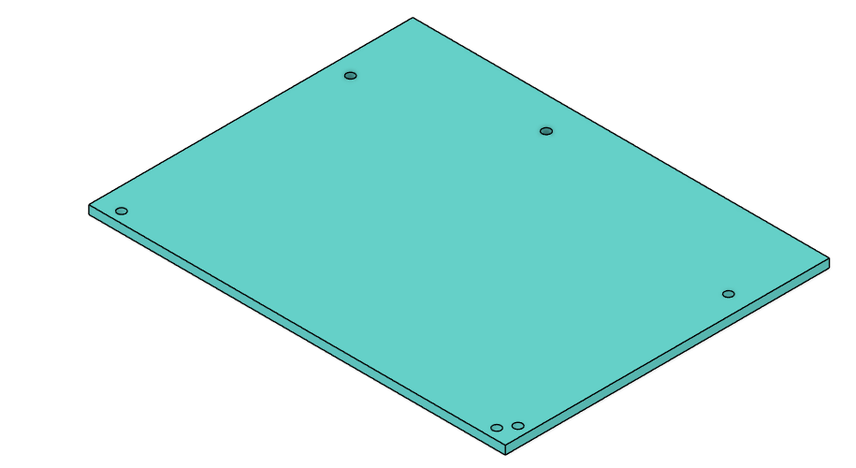 | Birch Plywood

A simulation simulation was performed on the chassis, modeling the loading of dropping the 3 kg weight from 25 cm above the chassis. The car was constructed from birch wood, requiring the simulation to be performed in ANSYS instead of Fusion 360, as Fusion 360 cannot simulate wood.

The Chassis is impact-loaded, which requires an Explicit Dynamics Simulation. To perform the FEA, the car was first simplified to just the structural components. Next, the components were treated as though they were bonded together to simplify the analysis further.

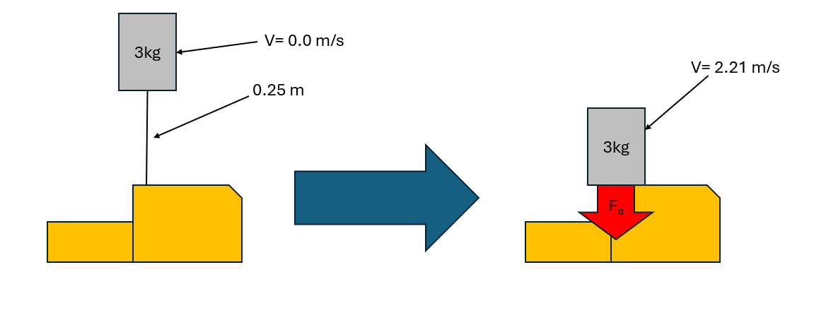
Figure 10: Impact Free Body Diagram
The FEA simulation modeled the load that was applied from a 3kg weight dropped from 0.25 m. In order to accurately model the situation while cutting down on simulation time, the weight as offset from the chassis by 1 mm in the model, and the weight was assigned an initial velocity of around 2.21 m/s. This particular value was computed from:
 | $V=√(2gh)$ | (8)
Additionally, the simulation's contact point roughly matches those experienced during the final performance.

The situation modeled falls under impact-loading, thus, the load is only applied over a very short duration. This is reflected in the duration simulated only being around 0.005 seconds.

A custom Birch wood profile for simulation; the material properties of interest were all gathered from Wang et al. and then imported into ANSYS. The weight dropped was ANSYS’ assigned steel material profile.
Table 5: Birch Wood Material Properties
Property | Value | Unit
Density | 693 | kg*m^-3
Young’s Modulus X | 9.4e9 | Pa
Youngs Modulus Y | 6.7e9 | Pa
Youngs Modulus Z | 1.11e9 | Pa
Poisson Ratio XY | 0.034 | NA
Poisson Ratio YZ | 0.439 | NA
Poisson Ratio XZ | 0.431 | NA
Shear Modulus XY | 6.1e8 | Pa
Shear Modulus YZ | 1.86e8 | Pa
Shear Modulus XZ | 2.06e8 | Pa
Tensile Yield Strength | 6.25e7 | Pa
Compressive Yield Strength | 3.13e7 | Pa

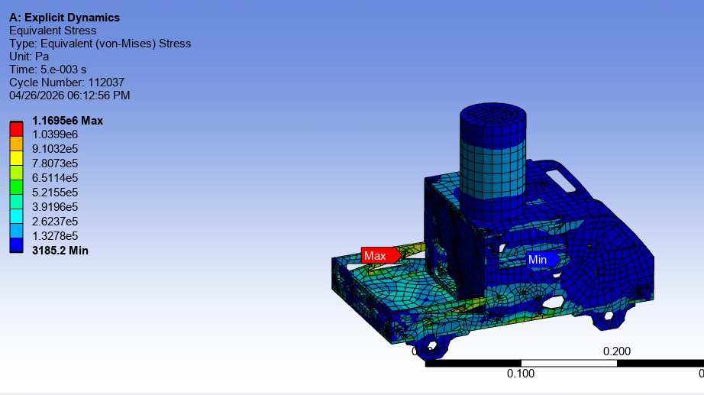
Figure 11: FEA Results

Table 6: FEA Results
𝛔_{max}= 1.17 MPa | 𝛅_{max}= 0.01597 m | $FS=\frac{σ_{y}}{σ_{max}}=$ 26.75

5. Reflection
Three major design decisions, reasons, advantages, and tradeoffs:
Three major design decisions that were made during this project include: use of delrin inserts, use of wooden dowels, and use of a hybrid dog clutch. The reason we used delrin inserts was to reduce friction at every location possible. This was incredibly challenging because it required foresight into where parts would rub against each other, the increased gap and tolerance required as well as the tolerance required for press fitting or super gluing the delrin parts in place. Despite these challenges, this change allowed for major efficiency improvements over previous iterations of the design.

The use of wooden dowels was the choice that had the most tradeoffs. While wooden dowels are exceptionally cheap and exceptionally light, they are also almost always warped, rough, and soft enough that when using set screws to mount them, the screws score the surface and eventually wiggle free. These issues required the tolerancing on the rest of the design to be incredibly tight, and as such many work around solutions had to be employed. One good example of this is the so-called “christmas tree gear” which takes multiple gears and connects them together on a hollow rod. Two set screws are used, one on each end. This allows the set screws to bite into the wood in two locations, and thus reduce the amount of skew the gears have in the axial direction.

The final major design decision was the choice to use a hybrid dog clutch transmission. The benefits of using such a design are that the size of the transmission can be incredibly compact and actuator efficient (small amount of servos). The challenges include a much more complex servo to dog linkage, and many alignment and tolerancing issues as well. Despite the challenges, once this mechanism functioned fully very little tuning and adjustments were required for reliable and fast shifting.

Biggest challenge encountered and how it was addressed:
The biggest challenge encountered was getting gear 4 to run smoothly. On iterations 1- 6 when shifting into 4th gear, the motor stopped turning and the transmission bound up. Even by hand, the gear train would not spin. This ended up being due to a variety of small issues that when compounded caused major interference and friction in the gear train. Most of these issues fall into the “buttery smoothness" category, and as such I will repeat them here: delrin inserts on shaft interfaces, delrin spacers between any two rubbing components, delrin shaft alignment inserts for idle gears that needed to spin in place, holes to reduce gear inertia, delrin-keyed gears for power transmission, and last but not least “christmas tree gears” to allow for shaft tolerance (simply a 3D printed mounting piece that reduced the skew of gears in the axial direction).

In short the team turned every location where friction occurred into an opportunity to improve design efficiency. The largest of these changes was changing the eccentricity of the gears. When a gear with a headset insert is placed on a shaft, the screw acts like a power screw that forces the shaft all the way to one side of the axle hole. This creates interference the size of the tolerance of the hole which results in binding. The simple fix was to offset the center of the gears by the tolerance of their holes so that the screw reset them into the perfect center of the shaft.

Description of design iteration that improved the solution:
The original transmission contained its own baseplate and walls, and screwed directly into the baseplate. The thought behind this was to make the transmission more accessible, since it would undergo constant iteration. Additionally, the chassis could be modified without needing to change components of the transmission. After putting this design into practice, it proved to make the assembly process excessively long, and many components difficult to access. Additionally, it required the chassis to be larger than necessary.

This design was altered so that the transmission dowels would ride in the walls of the chassis, effectively removing the entire original mounting system. The chassis size, amount of required components, and assembly time was significantly reduced.

Testing process and lessons learned from results:
Over the course of agility testing, the shifting from reverse to 3rd gear was inconsistent and subject to overshooting the line. This was a product of the 2nd servo’s shifting mechanism, which combines a dog clutch for reverse and fourth gear, with a sliding mesh for 3rd gear. Shifting into the sliding mesh was mostly at fault for the inconsistencies. To fully address this issue would have required a complete gear train redesign, so instead, the group decided to optimize the other aspects to reduce the time lost from imperfect shifting. For instance, optimal positioning when sending the IR signals to shift reduced some inconsistencies. Additionally, the motor was shut off temporarily when shifting from reverse to 3rd, which reduced overshoot and mitigated shifting difficulty. Ultimately, the car performed 7.5 out of 8 traversals.

Reflection on project experience (enjoyable vs. frustrating aspects):
The project experience was overall positive. The group feels that the technical aspects of the project were satisfactory. Also the group overall worked well together efficiently and effectively. The lecture material on gears came a bit too late to be helpful and could potentially be more beneficial if moved closer to the start of the semester.

Some points of feedback: Oftentimes there were deliverables or items listed in power points at the start of the semester that did not make it into the final rubric. This was incredibly frustrating and confusing. Also, many times our group was ready to work on the next deliverable, only to find that the task and instructions were not yet posted. Because our group met outside of class consistently, this hindered our ability to balance the work evenly over the semester. Lack of clear directions on specific deliverable items could also be improved. In many cases the discrepancies between the in-class slide show, TAs, word-of-mouth, and the rubric caused confusion, and unfortunately in some cases these discrepancies caused wasted time or needless effort.

Again, overall the project was positive and it is fairly easy to let the negatives outweigh the positives. The group hopes this feedback can be taken at face value and used for an even more enjoyable class! Thank you for a good semester - TEAM #7.

Evaluation of meeting stakeholder needs:
The stakeholder, George Alvarez, required a high level of achievement in the agility and quality categories, which required 8 traversals and 5 gears, respectively. The car was able to meet the quality requirements, but performed only 7.5 traversals. George required a moderate level of achievement for the speed, strength, and impact categories. The car met these requirements with a speed of 1.04m/s, strength of 3kg, and impact of 3kg at a 0.25m drop. The remaining categories, cost and efficiency, had a low level of achievement. The car met these requirements with a total cost of $27.43 and efficiency of 93.33%. Overall, the George Mobile met all of the stakeholder requirements besides the agility requirement, where it completed half a traversal less than required.

6. Appendix
Appendix A: Author Contributions
Section 1: Christopher Egly
Section 2: Phoebe Mihevc
Section 3: Neil Maushard
Section 4: Peyton Schwake
Section 5: Christopher Egly, Peyton Schwake, Phoebe Mihevc

Appendix B: References
- Software: ANSYS, Autodesk Fusion360
- Textbook/Websites:
https://laminatedplastics.com/delrin.pdf
https://www.adafruit.com/product/3777#technical-details
Wang, Tianxiang, Yue Wang, Roberto Crocetti, and Magnus Wålinder. "In-Plane Mechanical Properties of Birch Plywood." Construction and Building Materials 342, Part A (August 2022): 127852. https://doi.org/10.1016/j.conbuildmat.2022.127852.
- Arduino code used to control the gear box servos:
#include "Servo.h"
#include "IRremote.hpp" //both of these libraries should be installed already. To check: Tools --> manage libraries... --> filter by
// Type: change from "All" to "Installed".

Servo myservo; // defining a variable called myservo of Servo type
Servo myservo2; //servo for gears 3-5

#define IR_RECEIVE_PIN 7 //this is the pin reading the signal sent from the IR receiving sensor. Mine was logged to 8,
//yours should be too if you followed the tutorials sequentially. Otherwise, update this location accordingly

void setup() {
Serial.begin(9600); //turns on the serial monitor and specifies the upload rate. Arduino can talk to your laptop now. Make sure
// your serial monitor on the laptop is set to 9600 baud to communicate properly.
IrReceiver.begin(IR_RECEIVE_PIN, ENABLE_LED_FEEDBACK); //Tell the IR library what pin to expect IR signals from, enable the LED on the IR
// sensor to flash when a signal is being decrypted (helpful for debugging)
myservo.attach(2); //tell the arduino what pin the servo is attached to
myservo.write(110); //start by putting the servo at the middle position (angle 0-180)

myservo2.attach(3);
myservo2.write(83);

pinMode(4, OUTPUT); //establish pins 1 and 2 as signal sending pins (outputting) to send HI or LOW signals
// to the motor driver. A difference in signals between 1 and 2 (HI & LOW or LOW & HI) spins the motor (CW or CCW). Both LOW & LOW or HI & HI means no spin.
pinMode(5, OUTPUT);
digitalWrite(8, LOW);
digitalWrite(9, LOW);
}

int command;

//angles for gears 1-2
int neutral12 = 110;
int gear1 = neutral12+10;
int gear2 = neutral12 -10;

//angles for gears 3-5
int neutral35 = 83;
int gear3 = neutral35-5;
int gear4 = neutral35+10;
int reverse = neutral35-21;

//delay
int wait = 40;

void loop() {
if (IrReceiver.decode()) { //if an incoming signal is being decoded...
IrReceiver.printIRResultShort(&Serial);
command = IrReceiver.decodedIRData.command;
Serial.print("command = ");
Serial.println(command);
IrReceiver.resume();
}
//digitalWrite(4, LOW);
//digitalWrite(5, HIGH);
//myservo.write(0);
//delay(20);
//delay(1000);
//myservo.write(180);
//delay(1000);

if (command == 68){ // this is the command paired with the "left" button on the remote. Change this value to map
//different remote buttons to the servo's 0 position
myservo.write(0); //servo writes to 0 degrees. Change this value to see how you can program the servo differently.
}

else if (command == 82){ //neutral, button 0
myservo.write(neutral12);
delay(wait);
myservo2.write(neutral12);
}

else if (command == 22){ //gear 1 , left, button 1
myservo2.write(neutral35);
delay(wait);
myservo.write(gear1);
}

else if (command == 25){ //gear 2, right, button 2
myservo2.write(neutral35);
delay(wait);
myservo.write(gear2);
}

else if (command == 13){ //gear 3, middle, button 3
myservo.write(neutral12);
delay(wait);
myservo2.write(gear3);
}
else if (command == 12){ //gear 4, left, button 4
myservo.write(neutral12);
delay(wait);
myservo2.write(gear4);
}
else if (command == 24){ //gear Reverse, right, button 5
myservo.write(neutral12);
delay(wait);
myservo2.write(reverse);
}

else if (command == 70){ //up button, on
digitalWrite(8, HIGH);
digitalWrite(9, LOW);
}

else if (command == 21){ //down button, off
digitalWrite(8, HIGH);
digitalWrite(9, HIGH);
}

else if (command == 94){ //agility test, button 6
//set to gear 3
myservo.write(neutral12);
delay(wait);
myservo2.write(gear3);

//turn motor on
digitalWrite(8, HIGH);
digitalWrite(9, LOW);

for (int i=0;i<7;i++){

//delay for forwards movement
delay(4500);

//switch to reverse
myservo2.write(reverse);

//delay for backwards movement
delay(1200);

//switch back to forwards movement
myservo2.write(gear3);
}
//turn motor off
digitalWrite(4, HIGH);
digitalWrite(5, HIGH);
}

else if (command == 8){ // speed test, button 7
//turn motor on
digitalWrite(4, HIGH);
digitalWrite(5, LOW);

delay(200);

//switch to 4th gear
myservo2.write(gear4);
}

else if (command == 28){ //turn motor off switch to third gear, button 8
digitalWrite(8, LOW);
digitalWrite(9, LOW);

myservo2.write(gear3);
delay(500);
digitalWrite(8, HIGH);
digitalWrite(9, LOW);
}

}

Appendix C: Calculations
All calculations are in the body of the text.

